Diagonalize the Symmetric Matrix

EXPERIMENT-2

CODE: -

clc

A = input('Enter the square matrix A:');

n=length(A);

[X,D] = eig(A);

disp('The Eigenvalue of A are')

disp(diag(real(D)))

disp('The eigen vectors for the corresponding eigenvalues')

disp(X)

option = input('If you want to diagonalize by similarity tranformation then press 1 or any other key if you want to diagonalize orthogonal matrix.')

if(option==1)

P=X;

disp('Modal Matrix associated with A is ')

D=inv(P)\*A\*P

disp('D = inv(P)\*A\*P')

disp('Thus A is reduced to the diagonal matrix D through P by similarity transformation')

else

for i=1:n

x = X(:,i);

u(:,i)=x/norm(x)

end

disp('Orthogonal matrix associated with A is the matrix')

P1 = u(:,1:n)

disp('D=transpose(P1)\*A\*P1')

D = (P1)'\*A\*(P1)

disp('Thus A is reduced to the diagonal matrix D through P1 by orthogonal tranformation.')

end

Diagonalize the Symmetric Matrix

Input1: -

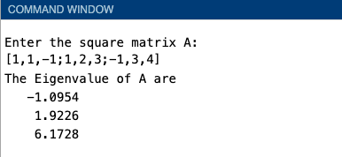

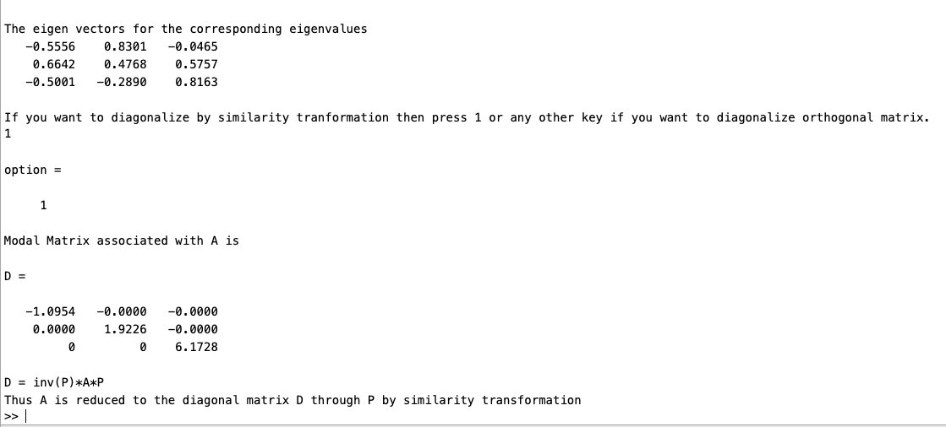

Input2: -

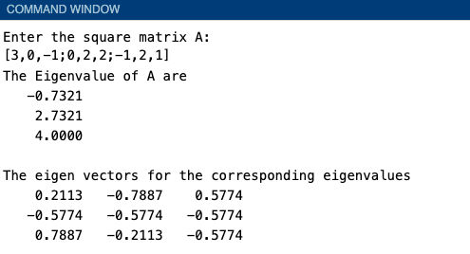

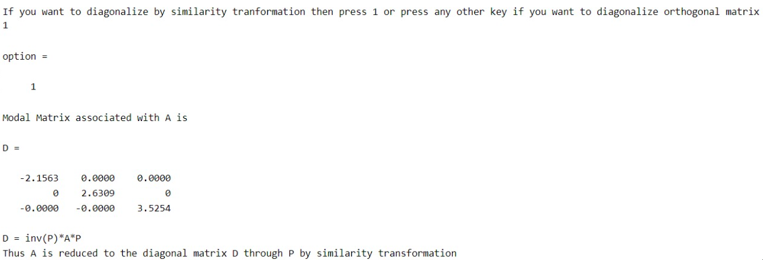

Orthogonal Matrix

Input1: -

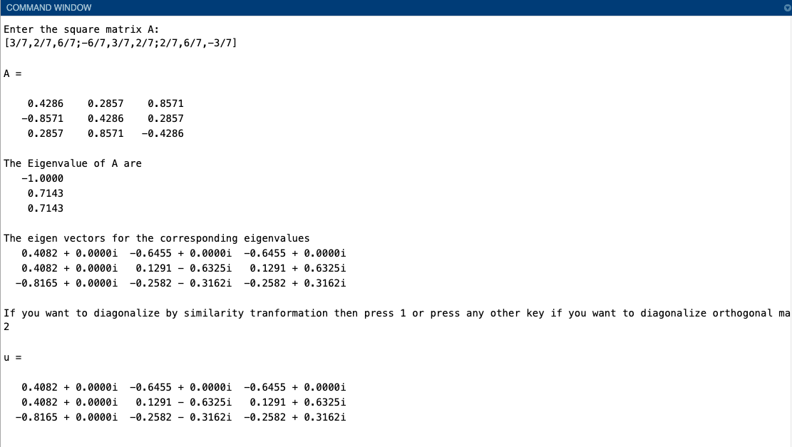

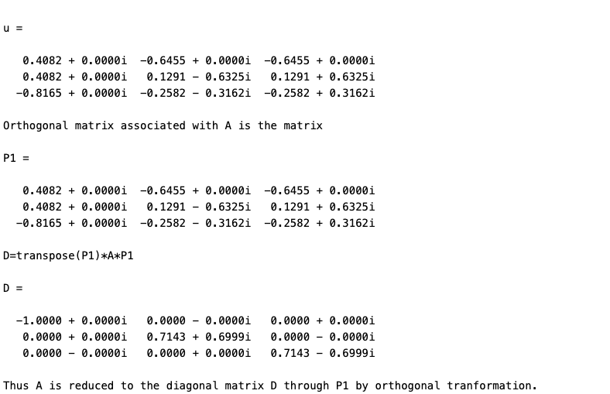

Input2: -

